Athletics Ireland Competition Entry Process

Checking Athletics Ireland Life Membership Number

Tale of Contents
Competition Entry Process 1
Check Membership in Athletics Ireland and get Athletics Ireland Life membership number 1

Competition Entry Process

- Enter athletics competitions at https://entry.athleticsireland.ie (Tipperary, Munster, National)
- Each competition no. currently open for entry is listed here, competition information includes, the date of the competition, a closing date + time of entries, selecting More info and View Flyer includes schedule of events, and location information. Once the closing date and time has expired, the competition is closed for entry and Enter button is removed. Competition information also available at http://tipperaryathletics.com, http://munsterathletics.com and http://athleticsireland.ie
- For Full User guide to entry process, select Help and dropdown to User Guide document, please read this document
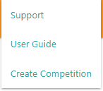
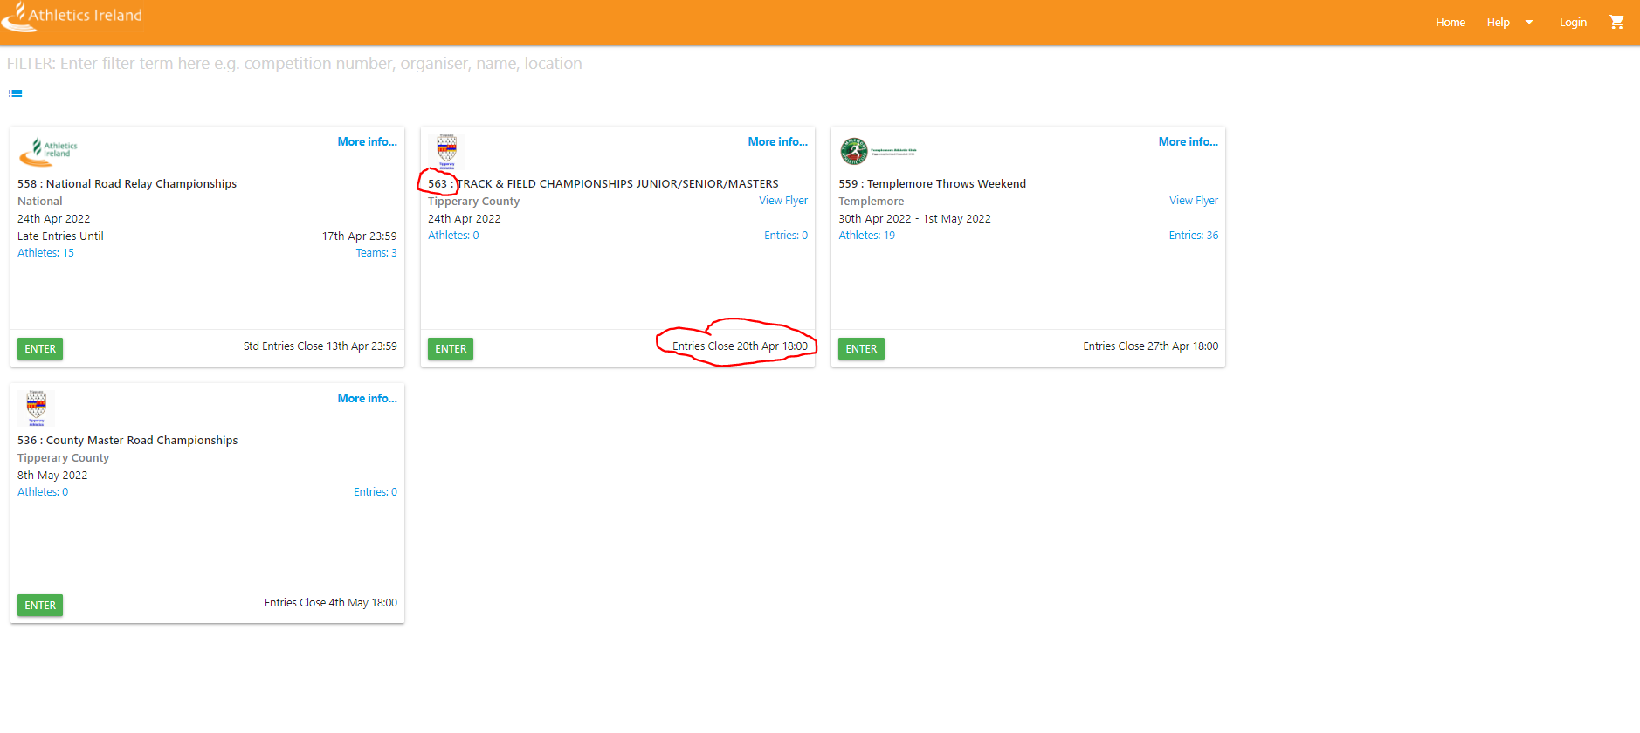
- To enter an athlete in a competition, select Competition and select Enter, the following page is displayed, use exiting username and password or for first time use select register as a new user.
Select Register as new user Existing User name and password
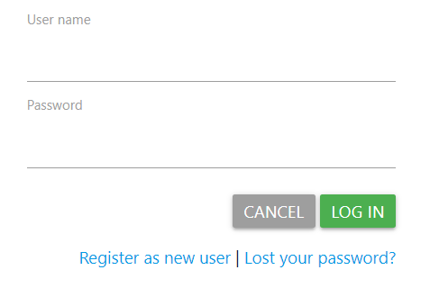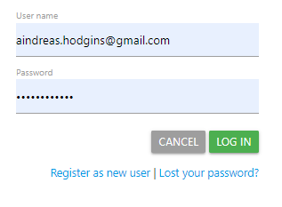
- Select Register as a new user, enter user name and email address. An email will be sent to set the pasword
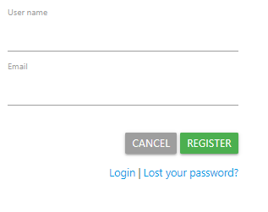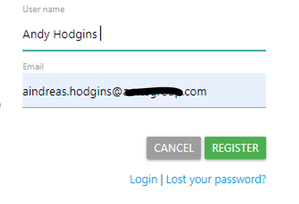
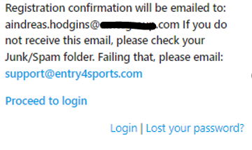
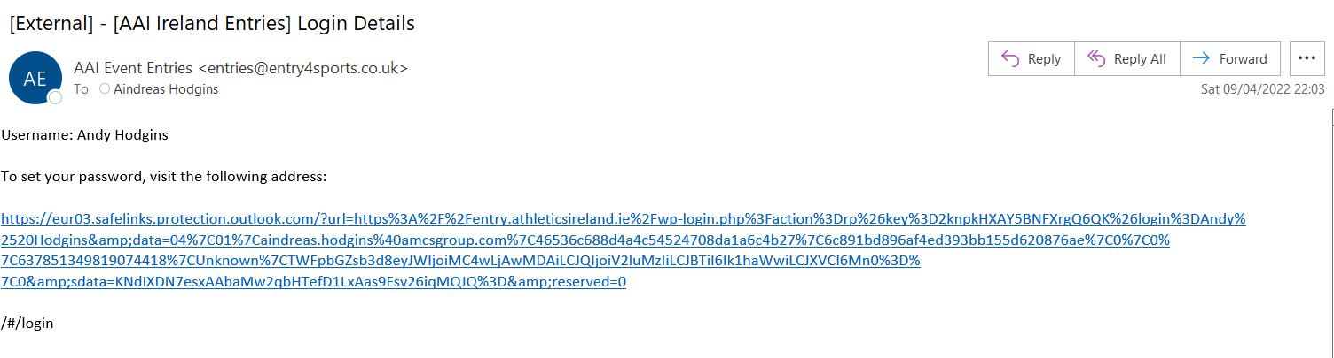

Click on link above you will be directed to a page to create a password
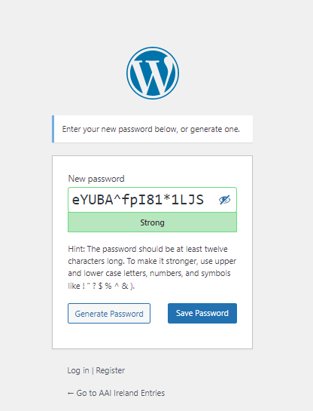

Enter a new password and select Save Password

- Login in with user name and password

- Select Enter on Competition, Go to page 9 of user guide and select Add Athlete

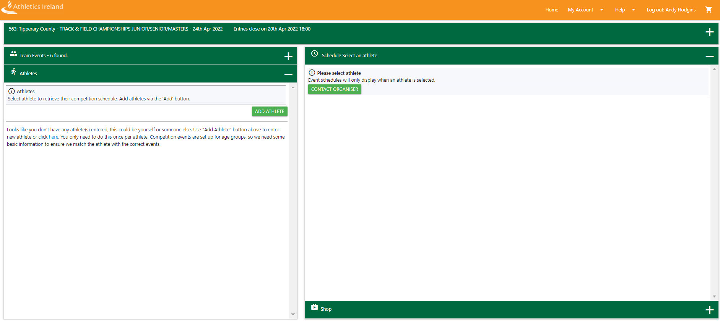

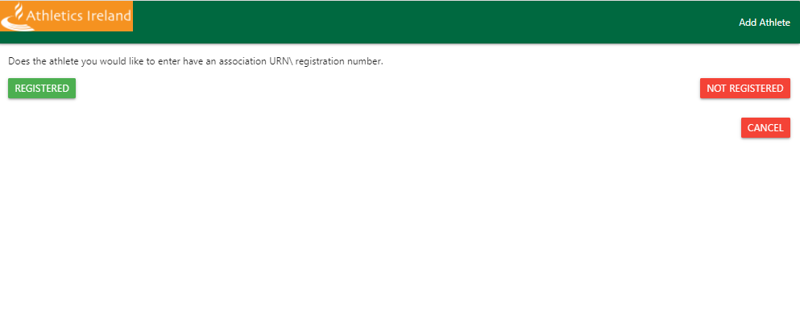

Select Registered
Fill the details, Athletics Ireland Life registration number and date of birth and select search
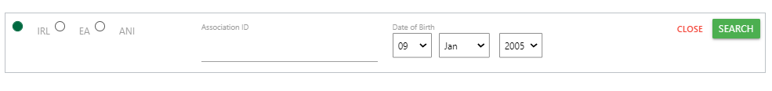

Athletics Ireland Life registration number is available from clicking on Check Membership in Athletics Ireland and get Athletics Ireland Life membership number

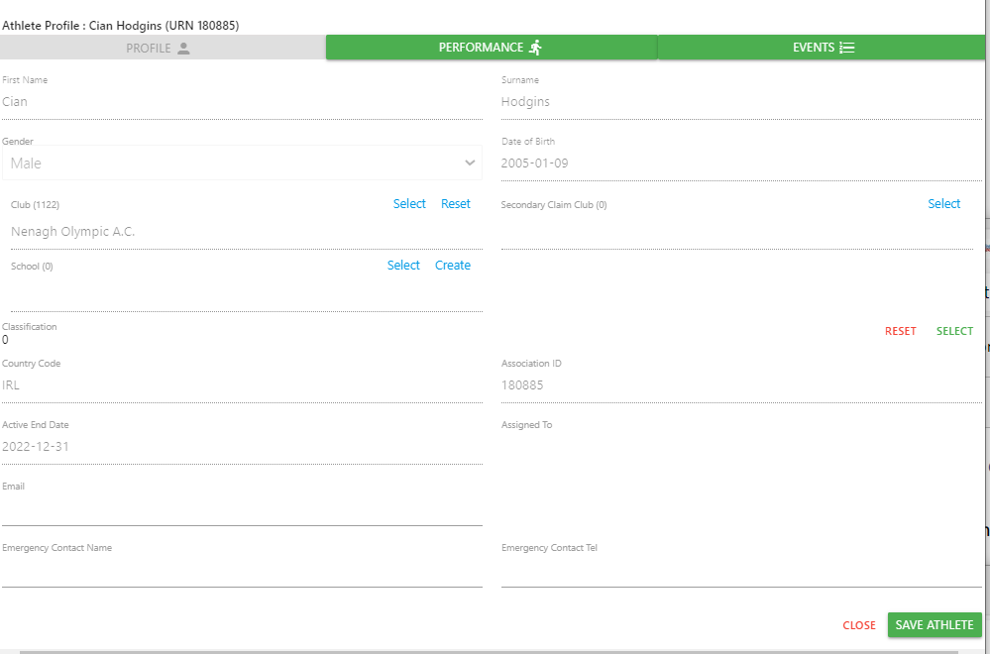

Select Save Athlete, then the scheduled list events open for athlete in competition is displayed.
You will only need to do this the first time you log on.
Scroll + Select events to enter

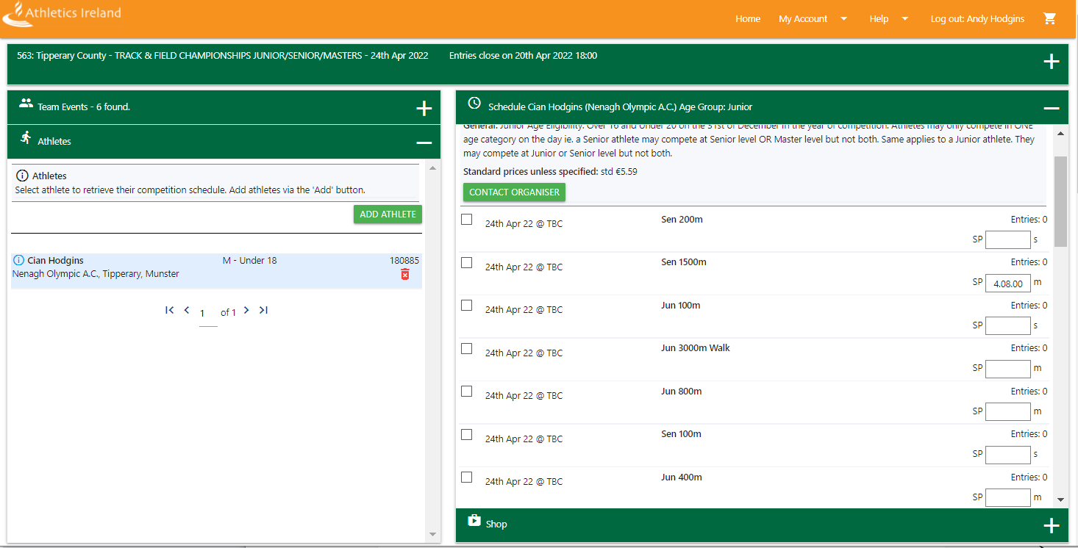

Scroll + Select event(s) to enter, Tick boxes

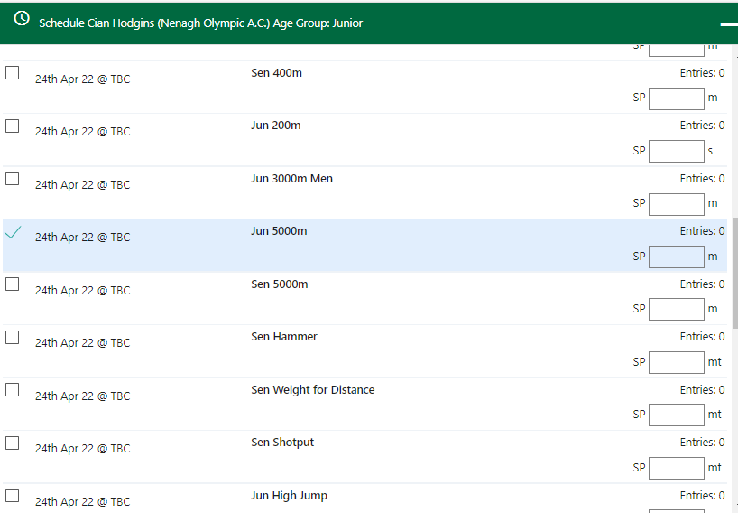

Click on basket to view events selected

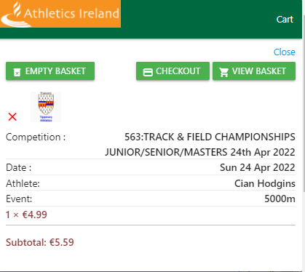

Click Checkout to complete payment

Next Screen
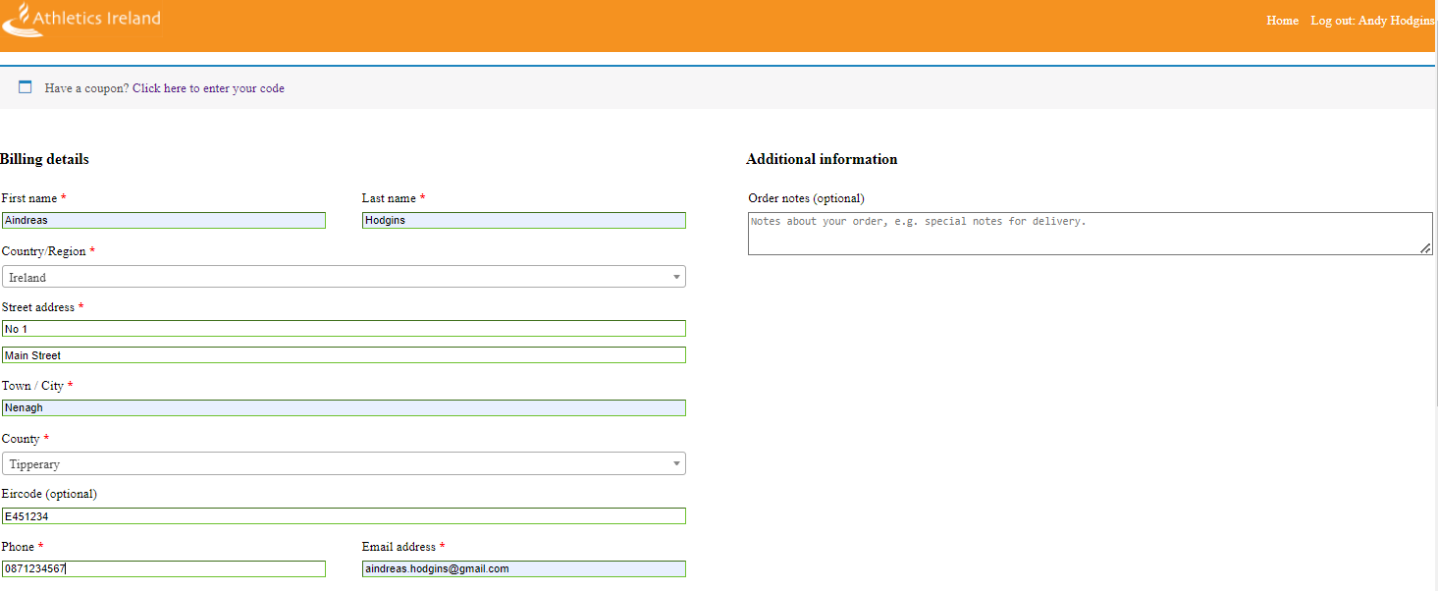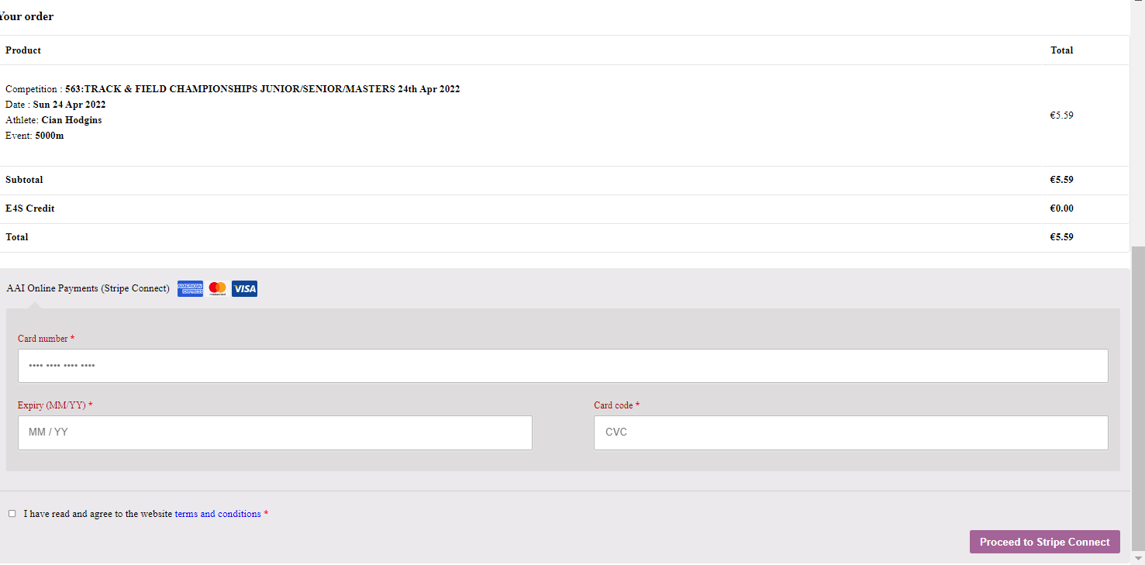

Fill in Card Details, Expiry, Card code and tick box to accept terms and conditions.

Then Select Proceed to Stripe Connect

Verification Screen for your card provider will be displayed, then a summary of payment

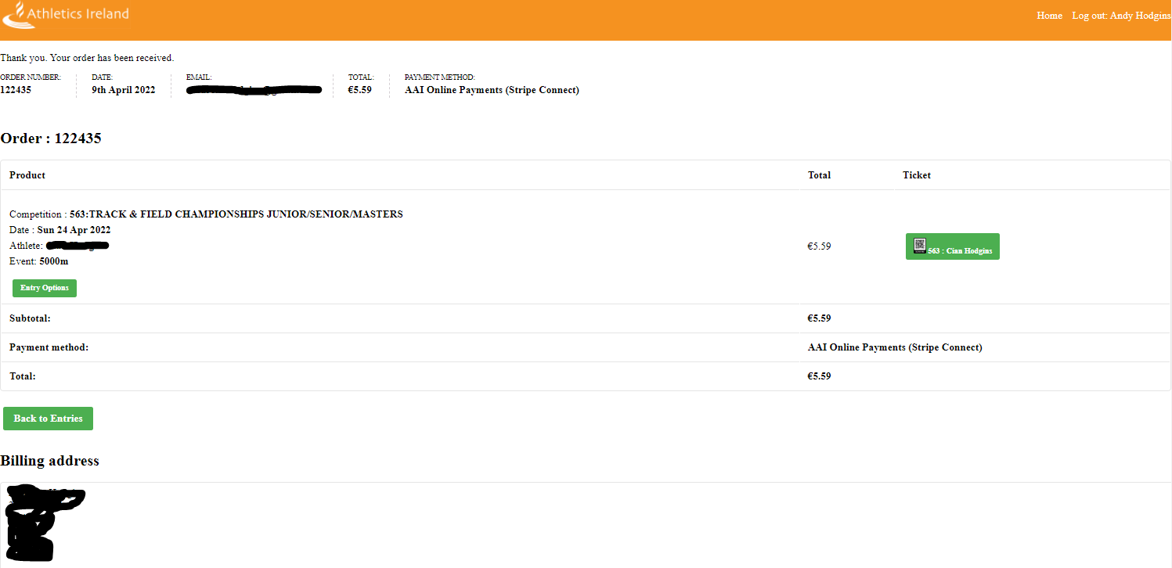

You will also receive email from entries@entry4sports.co.uk to email address supplied with details of entry

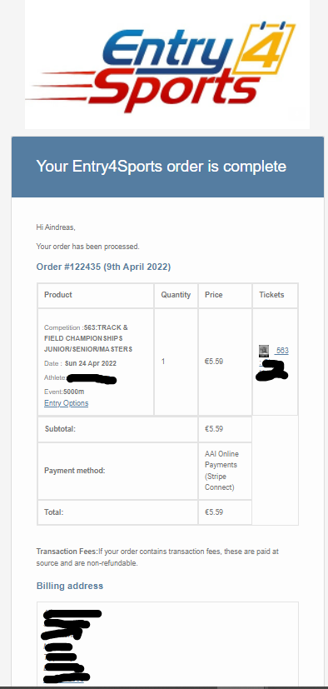

To confirm entry (You do not need to be logged in to entry.atleticsireland.ie)

Go back to entry.athleticsireland.ie, select competition number and click on entries
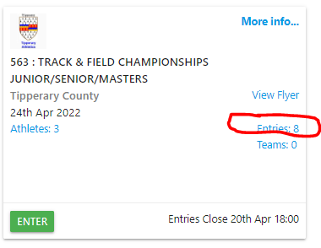

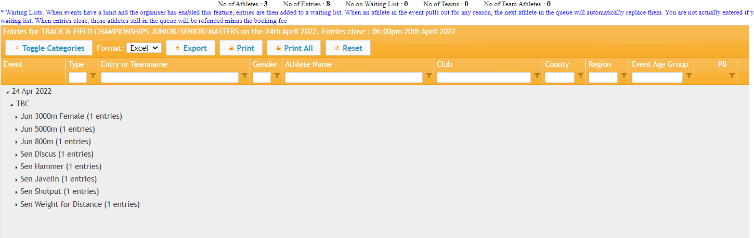

In Club field enter Nenagh to view all the Nenagh Olympic athletes or enter the Athlete Name in the field Athlete Name.

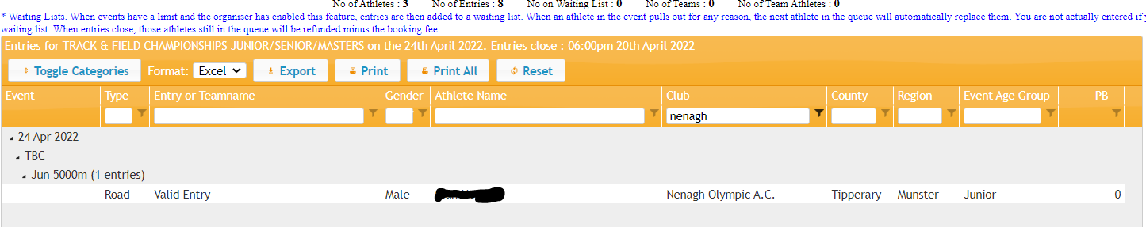

Your entry is confirmed

Check Membership in Athletics Ireland and get Athletics Ireland Life membership number

Click on http://athleticsireland.ie Select Manage My Membership at https://membership.athleticsireland.ie/check.html

Enter email address that the Athlete was registered with, and password.

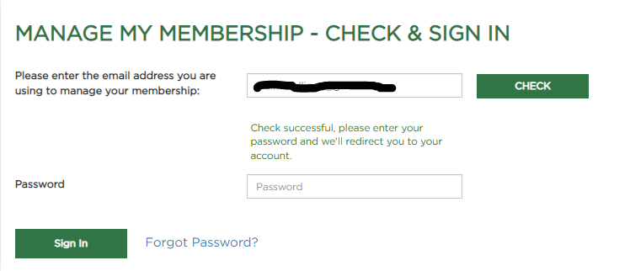
if account is not created you will get this message below and email will contain a link to register account.

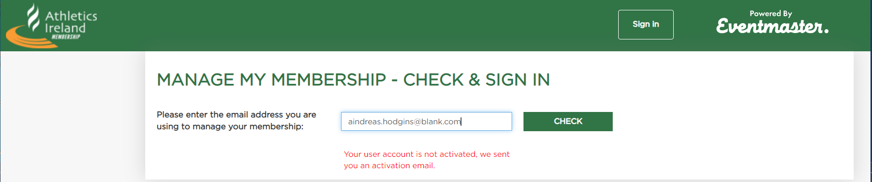

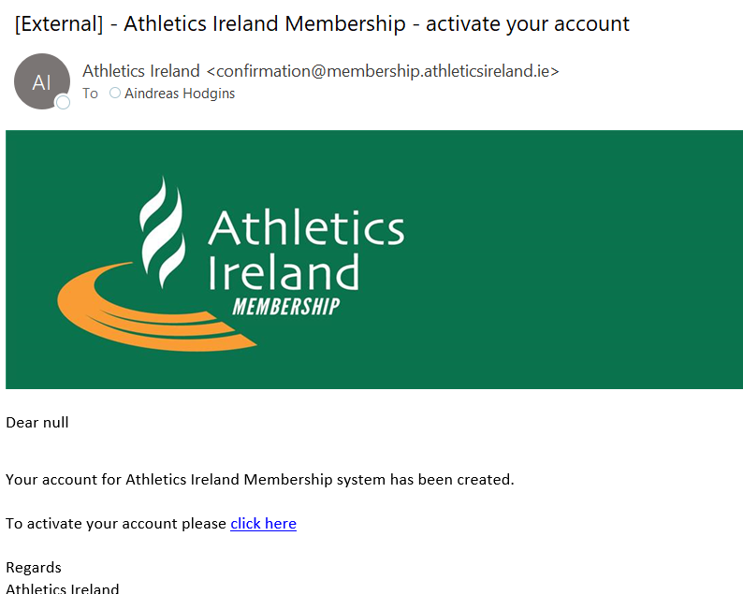
I
Click on link to activate account

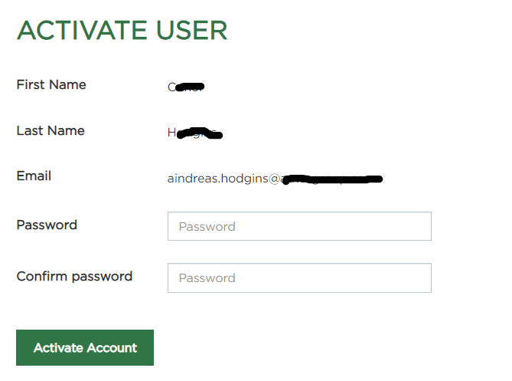

Enter Password and click Activate, then login with email and password, past membership information is included and options to renew or edit personal membership data.
Athlete Life Registration Number is listed under Life Reg Number.

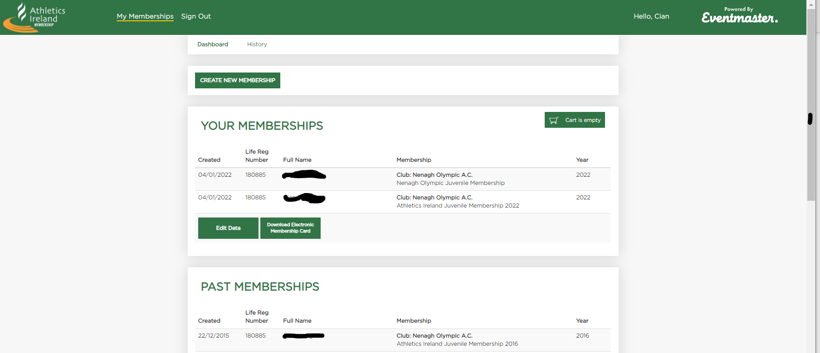

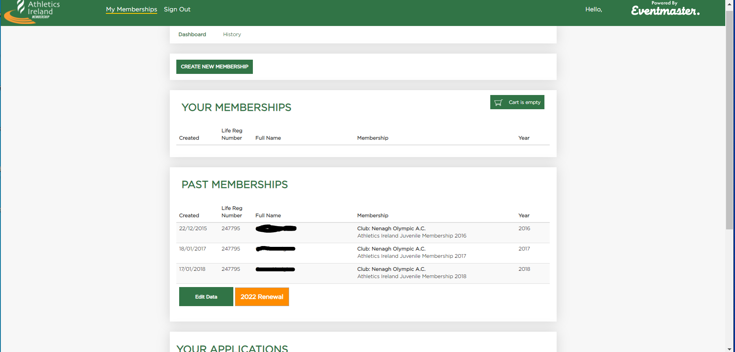

Click 2022 Renewal to renew membership, select accept code of conduct and then Continue.

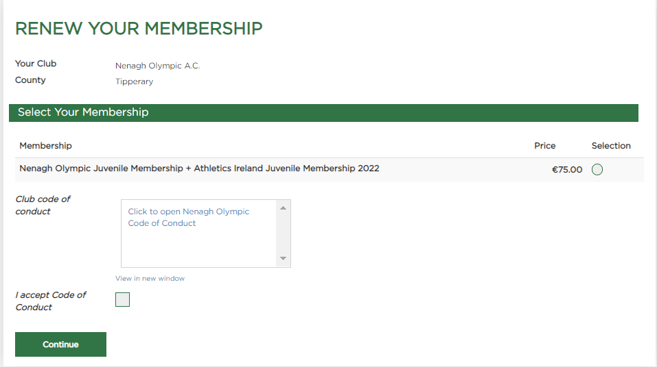

Select Proceed to Checkout

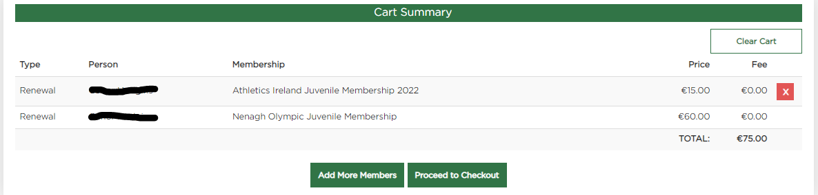

Enter Credit card details

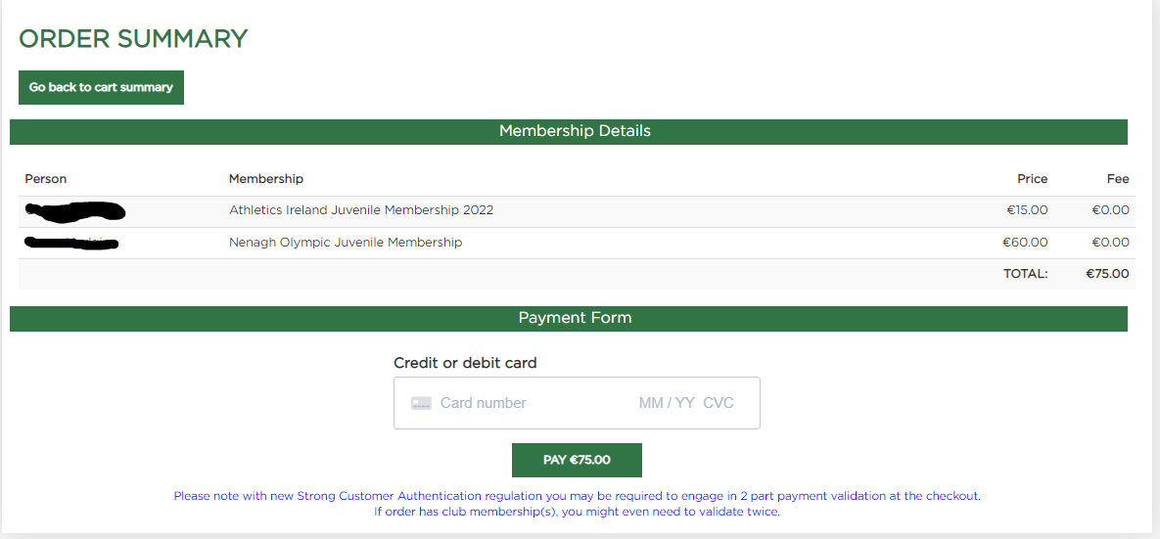

An email will be sent to email address used for registration when membership is paid.

