Secretary 085 182 6479 Established 1955

Code of Conduct

Updated September 2020

Content:
Code of Conduct for Athletes.
Code of Conduct for Coaches.
Code of Conduct for Parents.
Code of Conduct for all others.
Disciplinary Procedure.

Preamble.

Athletics is a sport which should be enjoyed by all who participate. Nenagh Olympic Athletic Club shall endeavour at all times to provide a safe, encouraging and nurturing environment for all our athletes and users. We want our athletes to reach their own personal goals and to strive to fulfil their potential whilst being proud to wear our Clubs colours.

Respect for self, for others and facility.

Ensure all Covid 19 guidelines and our Risk Assessment is strictly adhered to without exception by all parties within our Club.

ATHLETES ARE ENTITLED TO:
- Be happy, have fun, enjoy sport.
- Be listened to.
- Be believed.
- Be safe and feel safe.
- Be treated with dignity, sensitivity, and respect.
- Participate on an equal basis.
- Compete at a level at which they feel comfortable.
- Be afforded appropriate confidentiality.
- Say “No”.
- Protect their own bodies.
- Get help with bullies.
- Make a complaint and have it dealt with through an effective complaints procedure i.e. Child Welfare Officer involvement.

ATHLETES SHOULD ALWAYS:
- Enjoy the sport.
- Maintain respect for oneself, as this will form a strong basis for respecting others.
- Treat coaches, club volunteers and all other athletes with respect.
- Recognise and appreciate the efforts made by coaches and volunteers in providing training sessions and competition opportunities for them to compete in.
- Arrive for training and competitions in good time to prepare thoroughly.
- Turn up with appropriate kit for training.
- Warm up and cool down properly.
- Display consistently high standards of behaviour.
- Behave in a manner that avoids bringing the sport or club into disrepute.
- Recognize and applaud all good efforts from teammates and opponents.
- Be a good sport - “Win with modesty, lose with dignity”.
- Thank officials and opponents after competitions.
- Report any concerns to the Child Welfare Officers of the club.

ATHLETES SHOULD NEVER:
- Use foul/ abusive language or gestures towards any other person.
- Cheat.
- Use violence or physical contact.
- Harm team members, opponents, or their property.
- Harm or vandalise club property.
- Bully or use bullying tactics to isolate any athlete.
- Spread rumours or tell lies about anyone involved in the club.
- Chew gum – Strictly prohibited within the club.
- Use mobile phones or other devices during training sessions – such items will be confiscated until session is over.
- Commit a doping offence in accordance with the Anti-Doping Agency Rules published by Sport Ireland.

The above list is not exhaustive………

COACHES ARE ENTITLED TO:
- Be treated with respect by athletes, club volunteers, parents and in turn the coach should reciprocate to all the above.
- Hold training sessions for their athletes to ensure continuity of their athletes’ development.
- Be supported in their work by the club, parents/ guardians.
- Have equipment provided for training sessions.

COACHES SHOULD ALWAYS:
- Support the Code of Ethics and AAI guidelines regarding children and sport.
- Be Garda vetted.
- Attend a Safeguarding course biyearly.
- Promote a healthy lifestyle.
- Have relevant coaching courses and experience to work with athletes.
- Ensure safety of all athletes in their care.
- Be a good role model.
- Be reasonable in their demands of athletes age, fitness, energy, time, and enthusiasm.
- Invest in the athletes’ holistic wellbeing not their win/lose record – strike a balance between winning and welfare.
- Encourage fair play and treat all athletes equally.
- Liaise with parents/ guardians.
- Be able to make a complaint in an appropriate manner and have it dealt with through an effective complaints procedure.
COACHES SHOULD NEVER:
- Disrespect any other person within the club.
- Coach without the relevant vetting, knowledge, experience, or courses needed.
- Never ridicule or shout at a participant for making a mistake or losing.
- Tolerate foul play, fighting or foul language.

- Use any form of punishment on a child.
- Spend excessive amounts of time with individual athletes away from others.
- Develop physical or intimate relations with one of their athletes.
- Take a child on journeys alone in their car.
- Use alcohol, cigarettes, or illicit drugs before or during events or on trips with young athletes.
- Exert undue influence over an athlete to obtain personal benefit or reward.

The above list is not exhaustive……

PARENTS OF ATHLETES ARE ENTITLED TO:
- Be introduced to coaches and volunteers of the club.
- Have their child/ children trained in a safe environment.
- Have their child/ children trained by knowledgeable and experienced coaches.
- Be informed of any incident relating to their child/ children.
- Become members of the committee where feasible, and to take an active interest in the running of the club and activities i.e. Flag days etc.
- Be informed of club competitions, trips away or any other club activities.
- Make suggestions and have these reasonably considered.
- Have their complaint acknowledged and dealt with through an effective and confidential complaints procedure.
PARENTS SHOULD ALWAYS:
- Respect the rules and procedures set down in AAI Code of Ethics for children in sport.
- Show respect for all involved in the club.
- Encourage all child/children to play fair.
- Focus on their child/children’s efforts rather than performance.
- Focus on the enjoyment of the sport for their child/ children.
- Inform coaches of any special requirements or health concerns for their child/children i.e. diabetic etc.
- When dropping their child/children to training sessions make sure there are two coaches present before leaving.
- Collect their child/children promptly at the time allocated.
PARENTS SHOULD NEVER:
- Force their child to take part in sport.
- Use foul language.
- Punish or belittle a child for losing or making mistakes.

- Disrespect any person involved within the club.
- Use any form of punishment on a child.
- Argue with the coach regarding team selection.

CODE OF CONDUCT FOR ALL OTHERS:
- Be respectful to all involved within the club.
- Respect the equipment and facility ensuring their use is with the highest regard for the safety of oneself, others, the facility, and equipment.
- Clean up after oneself.
- Any damage to equipment/ facility will be incurred by that individual/ club/ group.
- Enjoy the facility.
- Pay the appropriate fee for the hiring or entrance to stadium

The above list is not exhaustive……

Disciplinary Procedures:
Minor Offence: i.e.
- Use of mobile phone during a session.
- Disruption of training session.
- Chewing gum during a session.
- Horseplay.
Action:
- Dealt with locally by the Coach conducting the training session.
- Repetitive behaviour -refer to Chairperson, who in turn will speak with athlete and Parent/Guardian.
- Consistent repetitive behaviour despite speaking with athlete and Parent/Guardian-Athlete will be excluded from training for a period agreed by relevant coach and Chairperson.
- Expulsion from Club.

Major Offence: i.e.
- Vandalism.
- Inappropriate behaviour.
- Disrespect to others/to equipment /facility.
Action:
- Counselling
- An informal conversation will occur between person involved and Chairperson / [Vice Chairperson] [if a bias exists].
- Involves an opportunity for the person to explain what happened.
- It highlights what was expected of them in their role.
- Action plan will be discussed to bring about required improvement.

- A written note outlining the action plan will be signed by Chairperson and person involved. Including a time frame for action plan to be carried out.
- Recorded in Clubs Incident Book.

- Verbal Warning.
- A meeting with person involved will occur with Chairperson [Vice Chairperson if a bias occurs].
- Advised as to the ongoing problem.
- Invited to explain why counselling did not work /or had not taken place.
- A representative for both parties may attend.
- A letter will be sent to the person confirming the discussion had, and actions that have been agreed, plus a timeframe will be agreed for resolution.
- Recorded in incident book

- Written Warning.
- Issue not resolved in the agreed timeframe, then a written warning will be sent to the persons home address.
- This letter will set out the nature of the problem.
- It will discuss the lack of resolution which was set out in the counselling and verbal warning stages.
- A time frame for resolution will be included by the Chairperson.
- Recorded in Incident Book.

- Final Written Warning.
- A final letter to try get a resolution.
- Timeframe for resolution will be at the Chairpersons discretion.
- If not resolved in this timeframe, it moves to Disciplinary Committee & recorded in Incident Book.

Complaint /Bullying /Unresolved Major Offence.

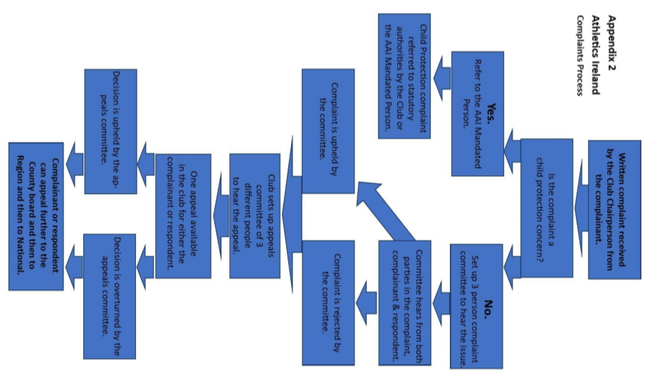

Gross Misconduct i.e.
- Intoxication
- Indecent behaviour
- Serious breaches of health and safety rules
- Fighting
- Gross insubordination
Action:
- Immediate expulsion from club.

